# 



# School of InfoComm Technology

**Applied Analytics Assignment**

Diploma in Cybersecurity & Digital Forensics

Diploma in Financial Informatics

Diploma in Information Technology

Year 2/3 (2021/2022), Semester 3/5

**INDIVIDUAL ASSIGNMENT**

(40% of AA Module)

**Deadline for Submission:**

**13 August 2021 (Friday), 23:59 HRS**

|  |  |
| --- | --- |
| Tutorial Group: | T02 |
| Student Name: | Chen Han |
| Student Number: | S10202961 |

**Penalty for late submission:**

10% of the marks will be deducted every day after the deadline.

**NO** submission will be accepted after 20 August 2021, 23:59 hrs.

Table of content

Table of Content

* Introduction --------------------------------------------------------------- 3
* Step 1 – Text Data Preprocessing ---------------------------------- 5
* Step 2 – Text Data Understanding --------------------------------- 12
* Step 3 – Classification Modelling ----------------------------------- 21
* Step 4 – Summary and Further Improvements ----------------- 33
* References --------------------------------------------------------------- 36

**Introduction**

In this assignment, I have been tasked to solve a text analytic problem using Python.

I was given a dataset (***bbc-text.csv***) consists of 2225 documents from the BBC news website corresponding to stories in five topical areas from 2004-2005. The csv file consists of two columns, first being the “category”, which are the labels for each document: business, entertainment, politics, sport, and tech. Second column is “text”, which is the BBC news stories/ Document.

The goal for this assignment is to preprocess and transform the data into either bag-of-words or TF-IDF matrix, then fit the data into various classification models to classify the BBC news stories into different categories and lastly, comparing the performance of each model.

To tackle this problem, I have broken down it into four steps and will explain each step with details in the later part of this report.

The first step will be text data pre-processing. Started off by extracting the data from the csv file and store it inside a data frame, followed by data cleansing using proper techniques such as removing stop words, stemming and lemmatizing. And lastly, the cleansed text data will be transformed into bag of words or TF-IDF matrix for classification modelling later.

For step 2, it will be text data understanding, first by extracting the keywords from each document using TF-IDF matrix, the keywords extracted can be then used for analysis using Association Rule Mining. The goal is to visualize and understand the associations between the keywords by category or by overall documents.

For step 3, it aims to use classification modellings on bag-of-word or TF-IDF matrix to classify the BBC news stories into different categories. And to evaluate the models performance using testing data and further improve the model performance by tuning model hyperparameters or further cleanse or transform the text data.

The last step is to summarize the findings, which can be a collection of accuracy scores from different models using either bag-of-word or TF-IDF matrix and choose the most suitable model to use to classify future data. And finally, some possible improvements to be made.

Importing Python libraries

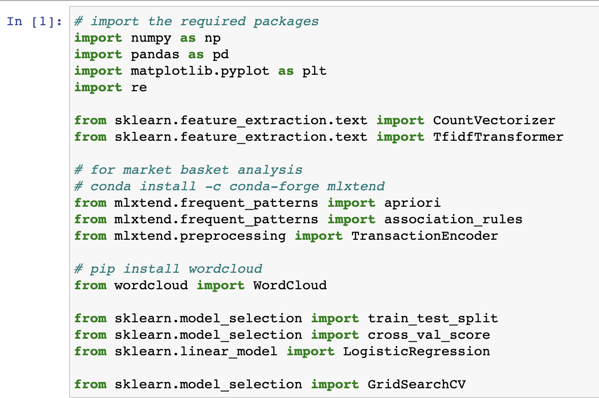

These are the Python libraries that might be used throughout the whole assignment. There are other libraries that are not included here will be imported in later steps.

First, the library NumPy is for managing large number of data, Pandas library for managing two-dimensional data structure with labeled axis (in this case, will be labelled columns), it is used throughout this assignment. Matplotlib allows us to plot graph according to the data given to provide a better understanding of the data. CountVectorizer and TfidfTransformer allows us to transform the text data into a data frame of only numbers using either bag-of-words or TF-IDF transformer.

Also, libraries like apriori and association rules are imported for data understanding later. And lastly, train_test_split, cross_val_score and LogisticRegression models are imported to do classification modelling in step 3, GridSearchCV is for hyperparameter tuning to maximize the performance of the model.

**Step 1 – Text Data Preprocessing**

* 1. Load the data

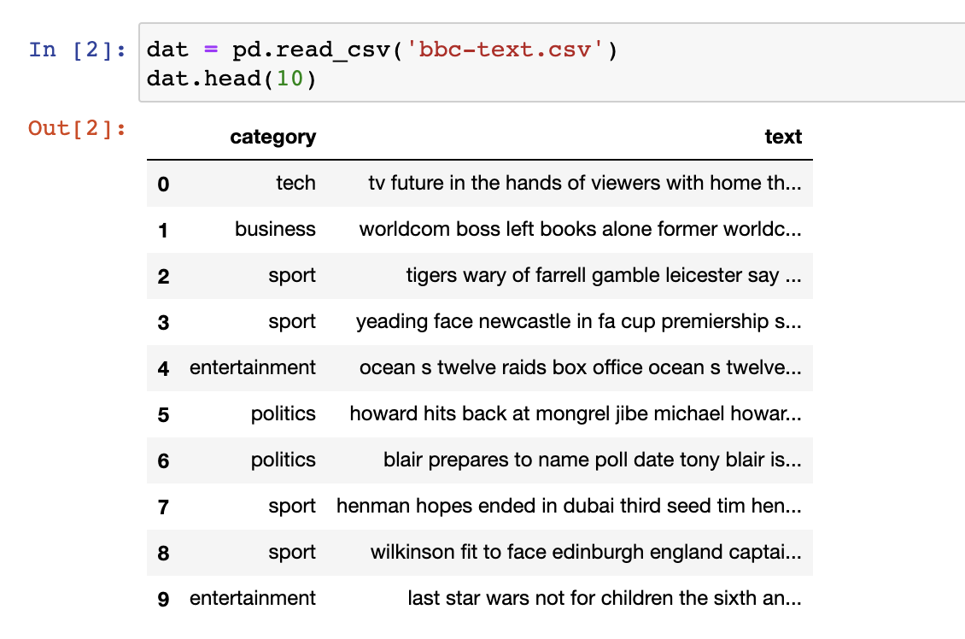

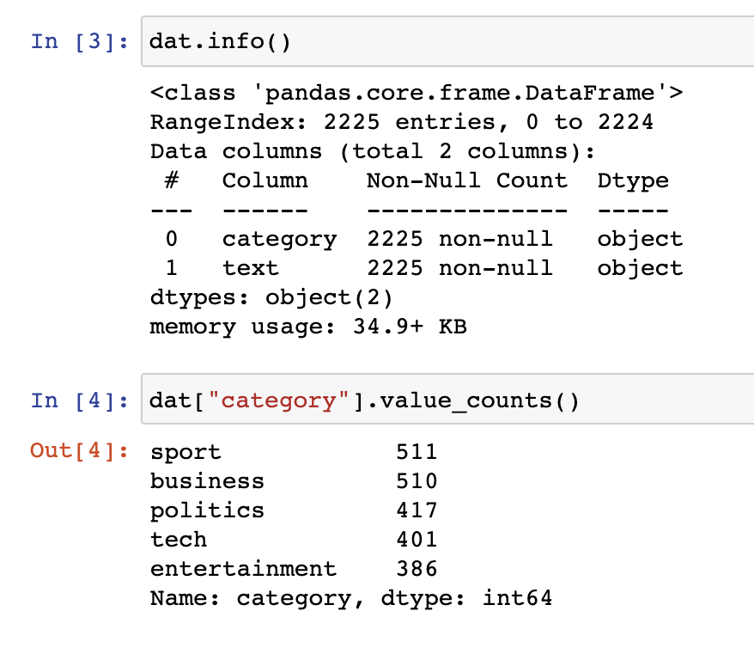

I use pd.read_csv() method in Pandas library to read the csv file (bbc-text.csv) and store it into a pandas data frame with two columns labelled as category and text.

There is a total of 2225 rows of data, the data itself are quite clean, none of the rows contains null value.

For the first column – category contains five values which are sport, business, politics, tech and entertainment. These names are the label for its corresponding text, which will be used as “answers” later for training and testing.

The value counts for each category are quite evenly spread-out, with sport and business having the greatest number of rows of around 500, and the remining three are around 400 rows.

* 1. Data cleansing

Data cleansing helps to remove all extra words that tends to have no meaning or convert the words with different forms back to their base forms. (E.g Plural to Singular).

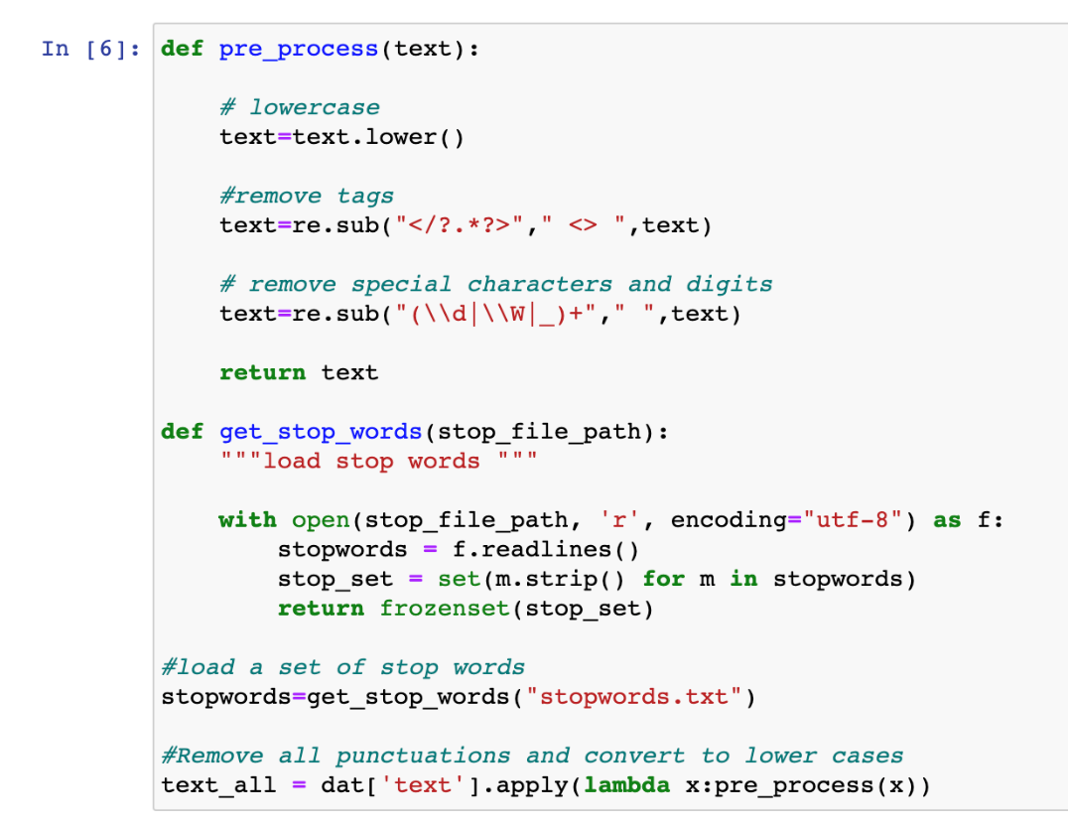

The code above declaring two functions, pre_process() and get_stop_words().

By using a lambda function in the dataset with pre_process() method, it loops through each row of the dataset, takes in text data, convert all the characters into lower cases and use regex function to remove all the tags, special characters and digits. And lastly return the processed text data back to the data frame.

The get_stop_words() function are used to load all the stop words from the stop_word_path declared, find the file in the directory and return a frozenset of all stop words to be used later.

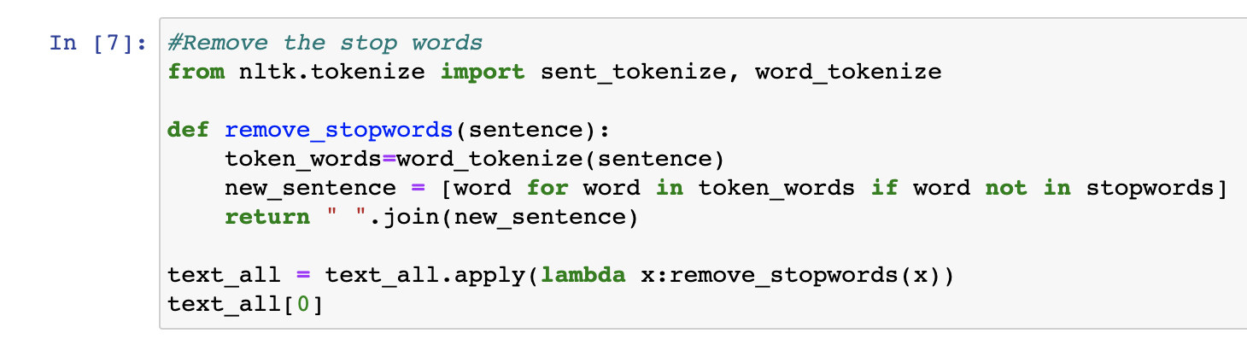

After gotten a list of stop words, this step declared a function to remove all the stop words in the text data.

By applying a lambda function into the dataset, calling the remove_stopwords() function each time looping through the dataset. It takes the text data of each row as parameter, tokenized each text data (as by now, the text data is no longer containing punctuations and special characters, only left a space between each word in lower case). And a simple list comprehension that helps to filter out words that appeared in the stopwords list. Lastly, join back the words and return the result back to the dataset.

Here is a comparison of text data before and after pre_process and removing stopwords.

Before:

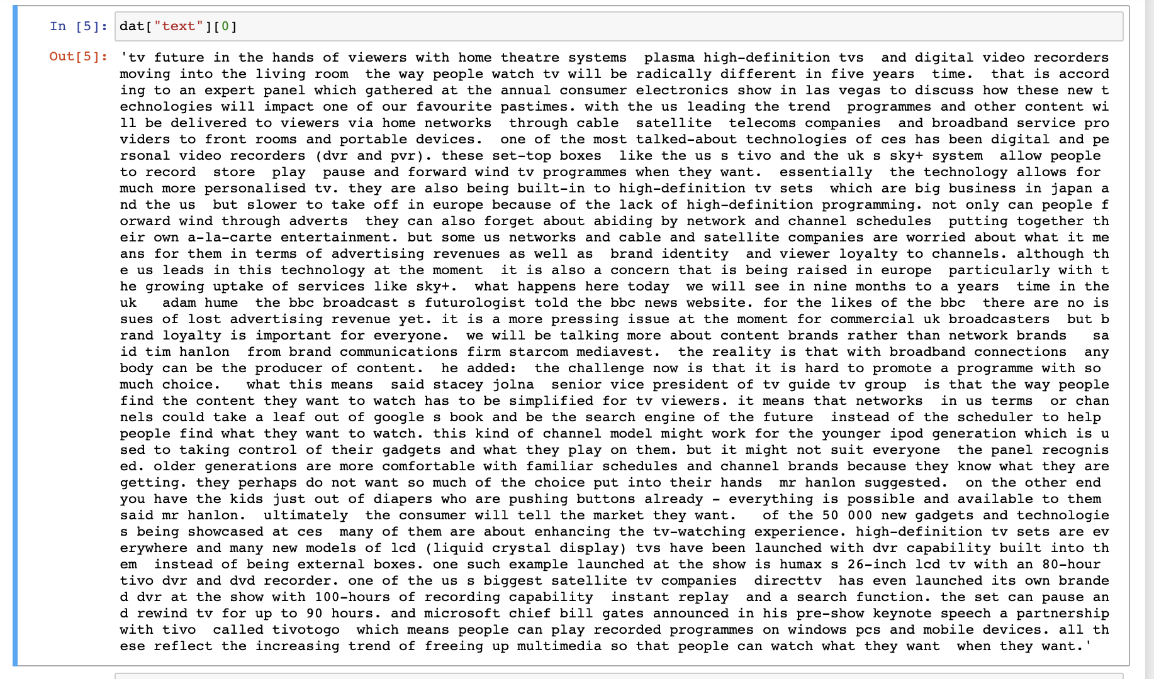

After:

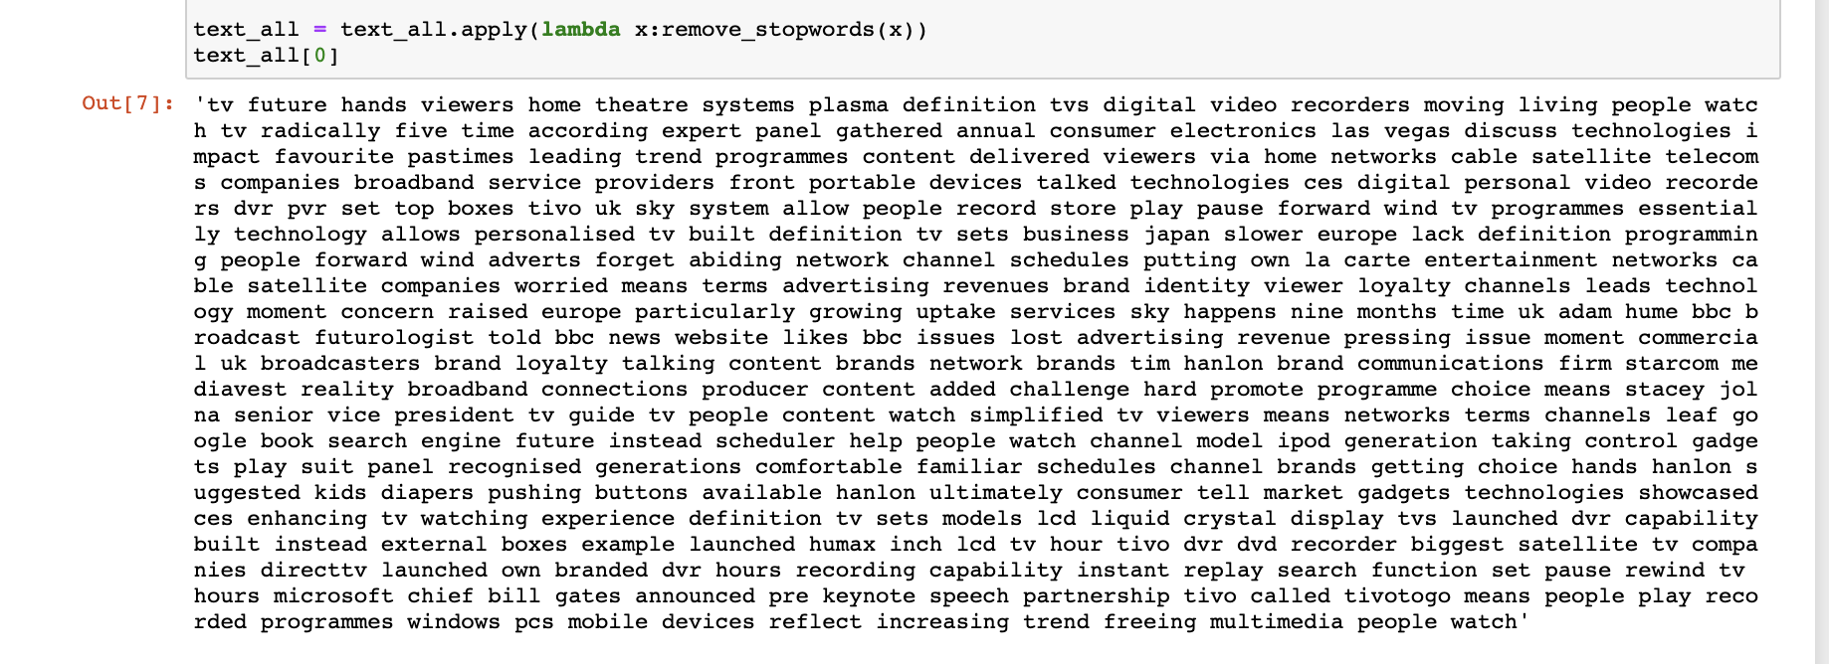

It is obvious to see that the word count has dropped after removing all the stopwords. But there are still words with plural forms.

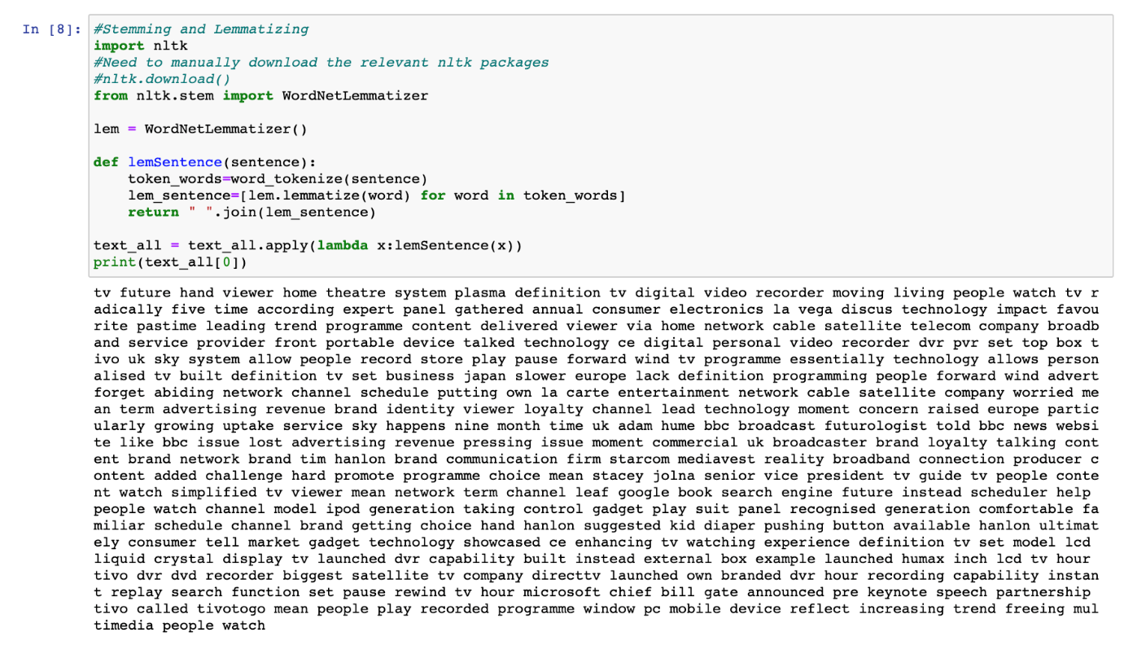

Next, by importing the nltk library packages, WordNetLemmatizer (need to install relevant packages manually by calling nltk.download()), creating a function that use lemmatization to convert the words back to their base form.

Now, words such as “hands” and “viewers” previously has now converted to “hand” and “viewer” in the text data. However, due to the limitation of the algorithm, there are still words that are not being converted back to their base form.

* 1. Transform Text Data (bag-of-words)

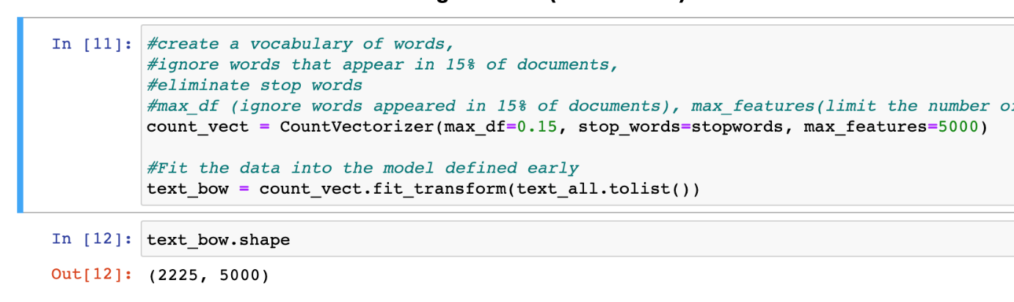

First by initializing a CountVectorizer model that is used to transform a given text into a vector based on the frequency (count) of each word that occurs in the entire text.

The parameters passed in are max_df, which ignore words that appeared in 15% of documents, stop_words which helps to eliminate stop words (done earlier on), and max_features which is the maximum number of words that are allowed in the data frame.

Next, fit the text_all dataset into the CountVectorizer and name it as text_bow.

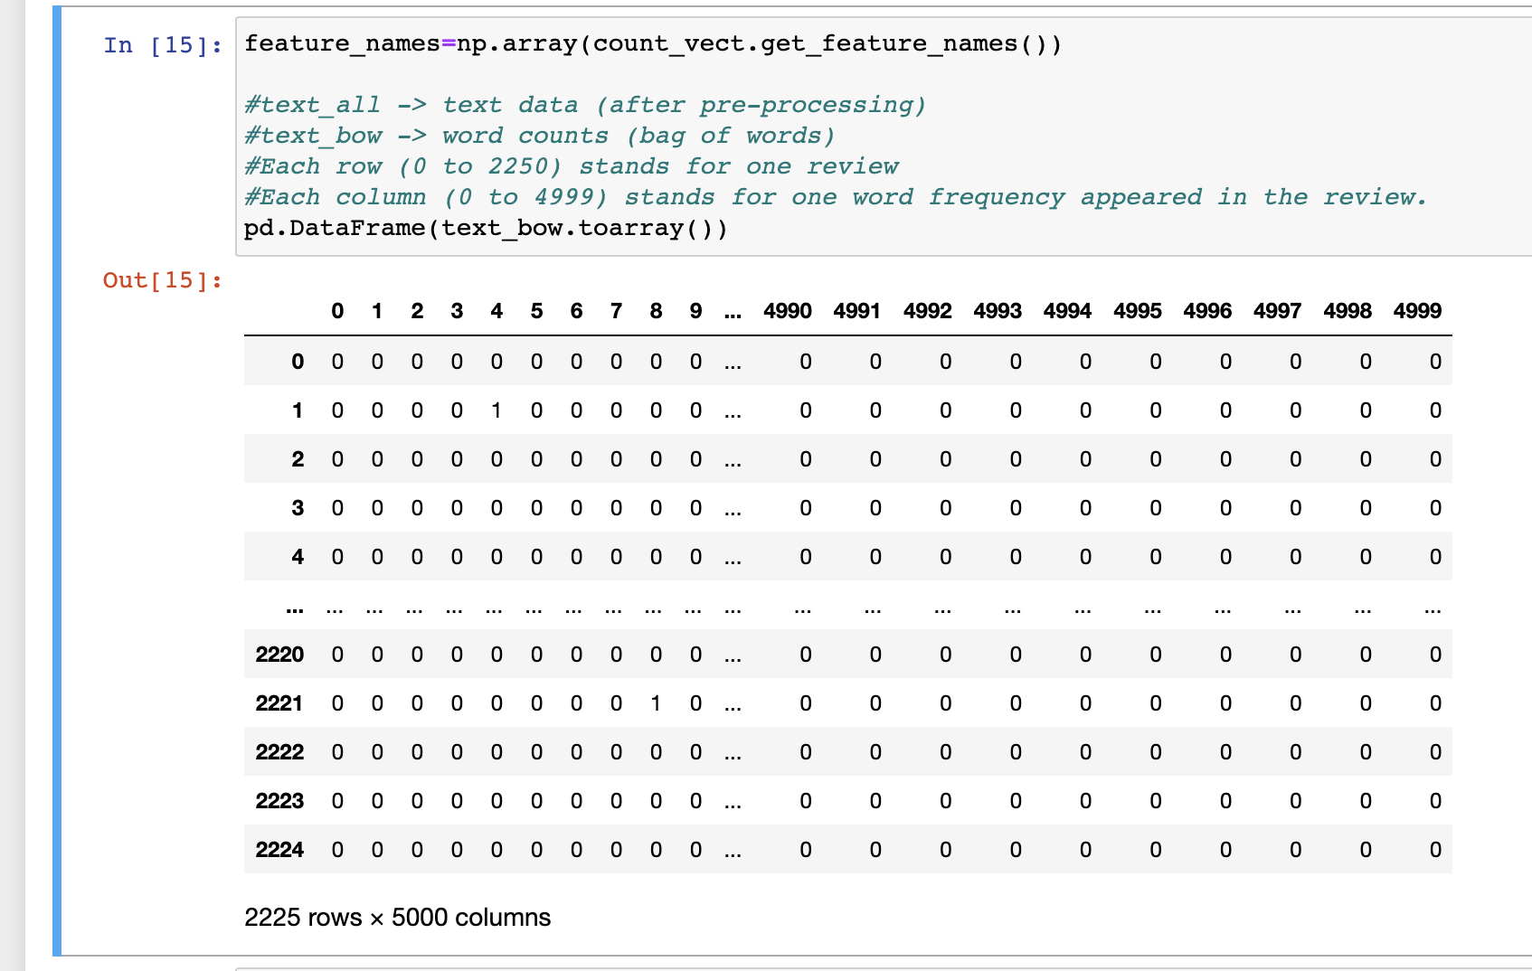

This is a visualization of text_bow data frame, there are total 2225 rows, each row stands for one text data, and a total of 5000 columns which are the unique features (words) in the document, each column stands for one word frequency appeared in the text data.

Here are the words with highest and lowest frequency in the documents

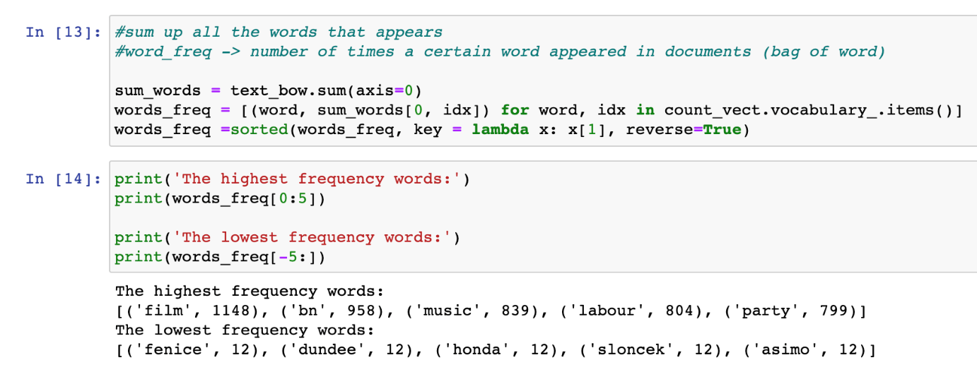

* 1. Transform Text Data (TF-IDF matrix)

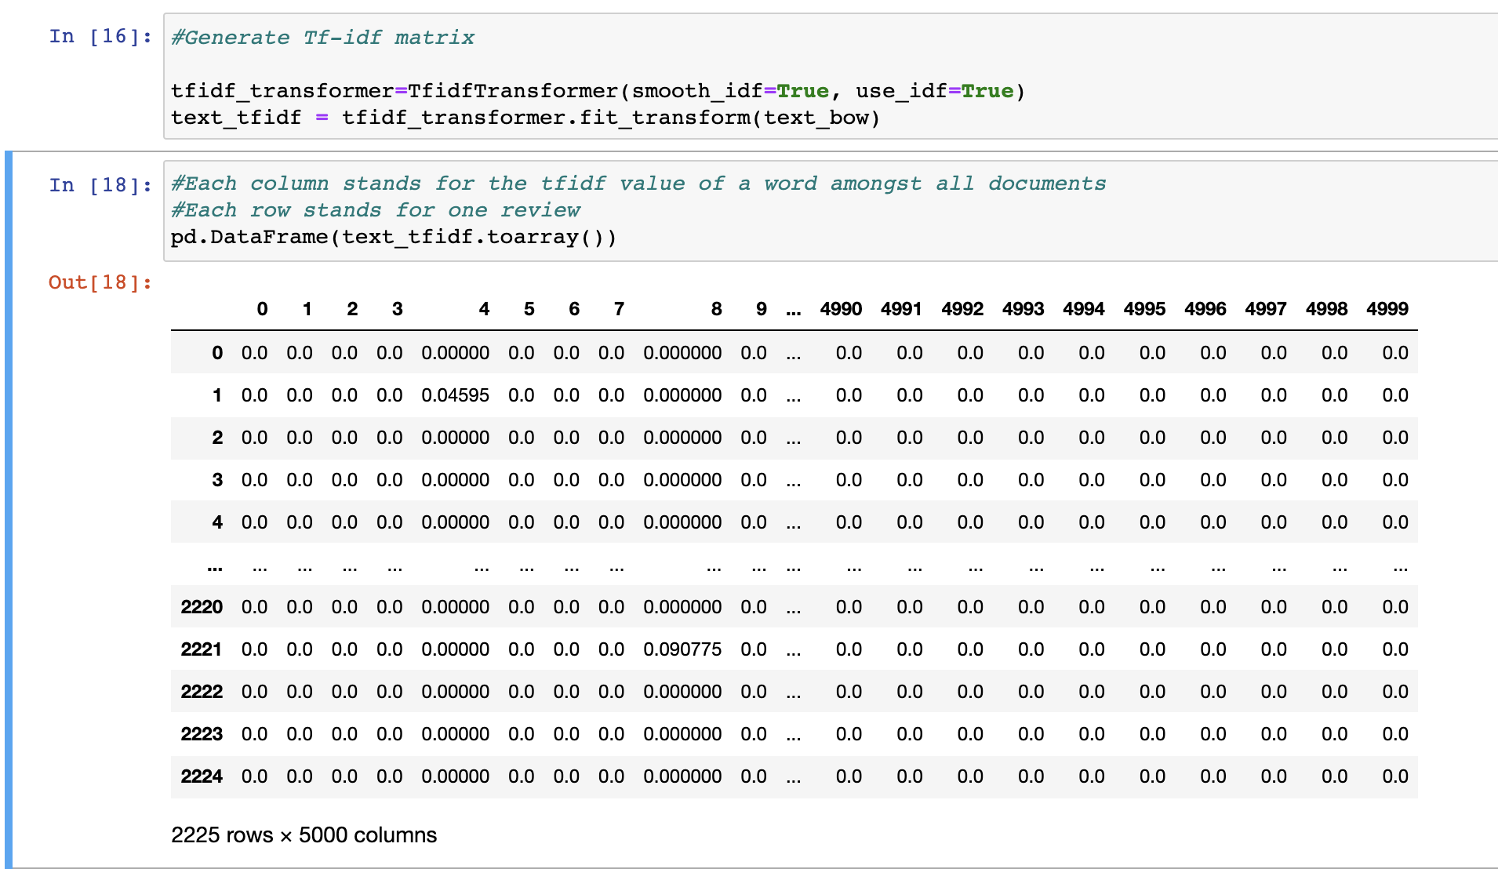

Now, it is time to transform the text data into TF-IDF matrix.

First by initializing a TfidfTransformer and fit the text_bow array identified earlier on into the model. This helps to replace the word count of each word into a TF-IDF value of a word amongst all documents. TF-IDF reflects how important a particular word is to a document in a corpus. The higher the value of TF-IDF score, the more unique the word to the document. The text_tfidf matrix will be used for classification modelling in step 3.

The followings are the features with lowest and highest tfidf scores

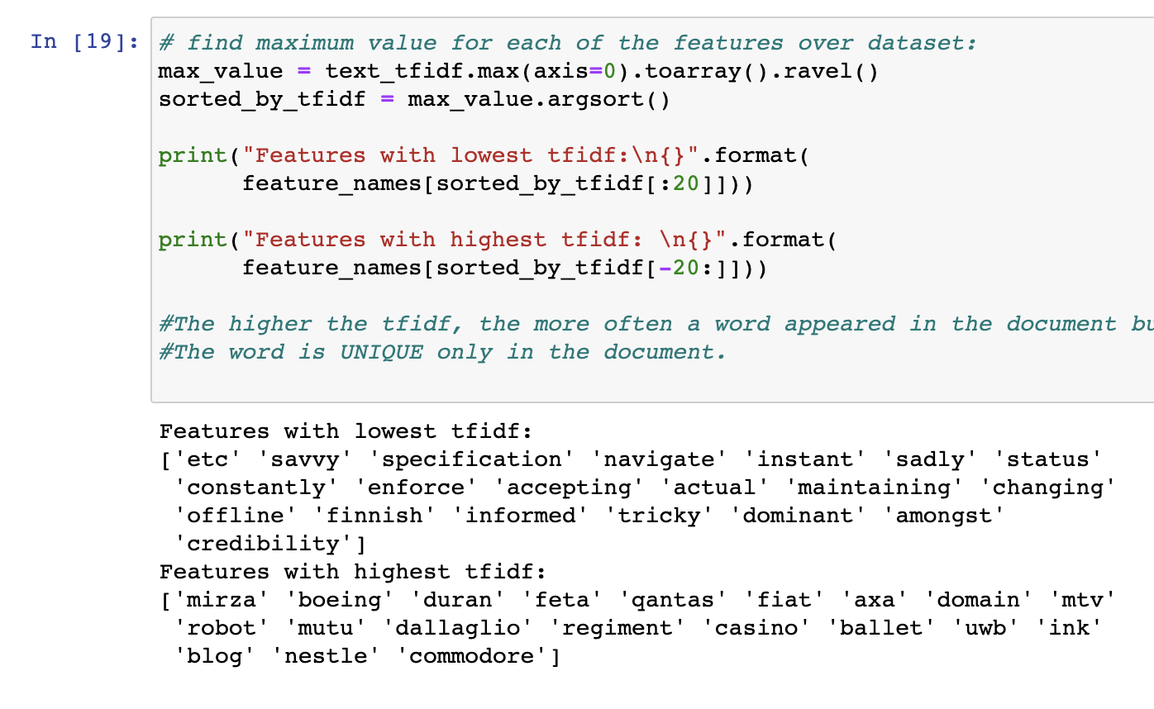

**Step 2 – Text Data Understanding**

2.1 Extract keywords using TF-IDF matrix

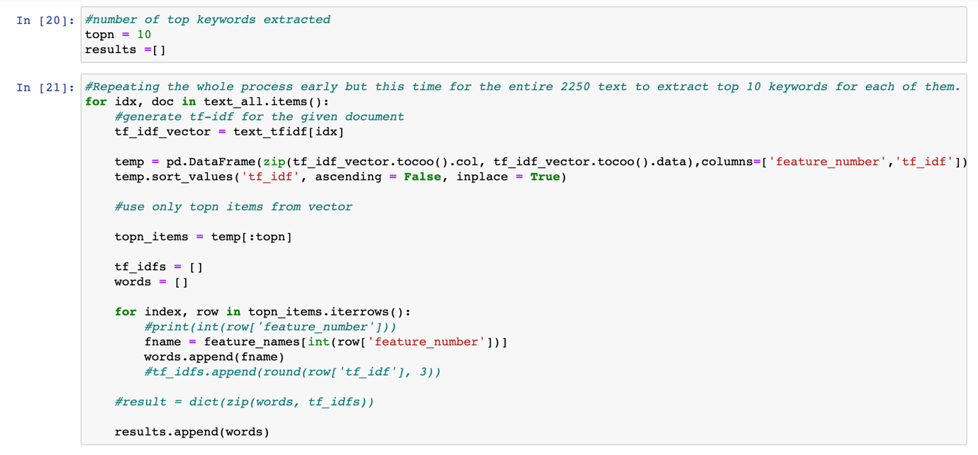

First, extract top 10 keywords with highest tf-idf score from the text_tfidf matrix. As there are total of 2225 rows of data, there will be a total of 2225 * 10 = 22250 keywords extracted out. The keywords extracted are stored in a list called “results” for text understanding later.

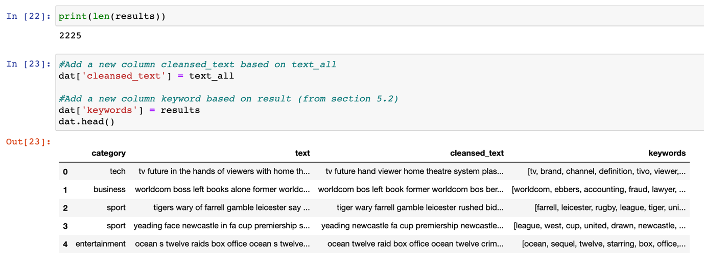

The list “results” is a nested list, which consists of 2250 lists of 10 keywords.

Next, adds two new columns: cleansed_text and keywords into the dataset.

2.2 Association Rule Mining on Keywords - Total

Association rule mining is a rule-based machine learning method for discovering interesting relations between keywords in a large dataset. It identifies frequent association rules which consists of an antecedent and a consequent. By using support, confidence and lift values to measure associations, it helps us to find interesting findings about the dataset and its keywords.

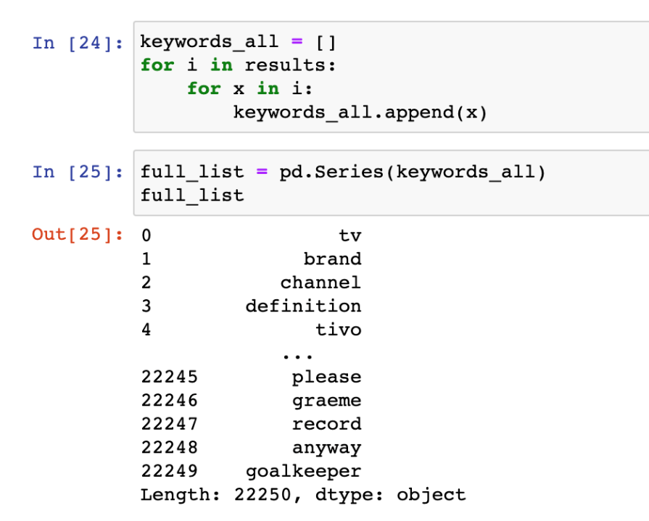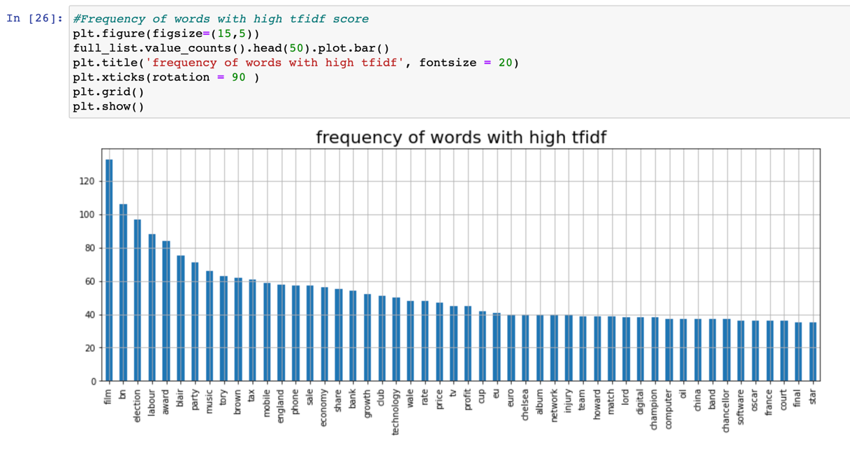

First by converting the “results” list into a 1d array of all 22250 keywords.

And visualize the word frequency of highest tf-idf scores using a bar chart.

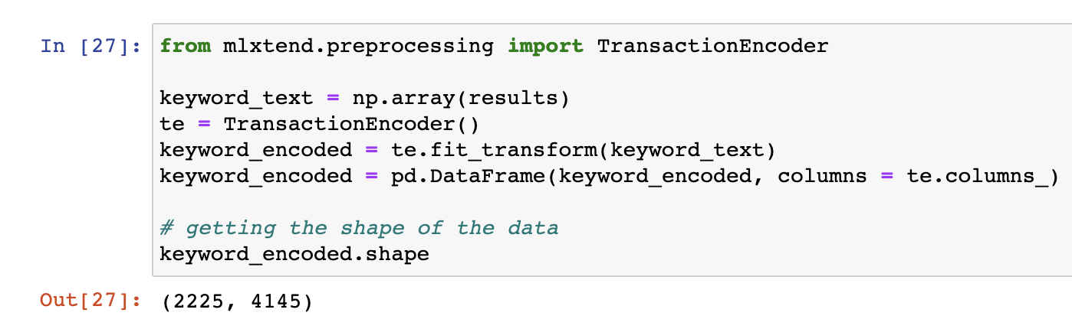

Next, import TransactionEncoder from mlxtend.preprocessing library, this package helps to fit the keywords into a 2d array, 2225 rows stands for the number of documents, there are also 4145 columns, each column stands for a unique keywords from the 22250 keyword list, each column also contains a numeric value corrosponding to the row (text data) that indicates how many time the keyword has appeared in the document.

(Similar idea to bag-of-words transformer)

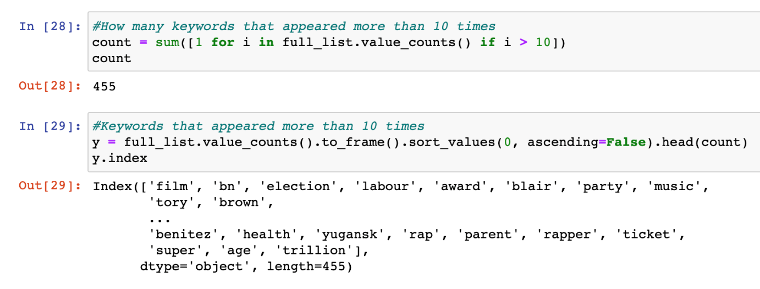  
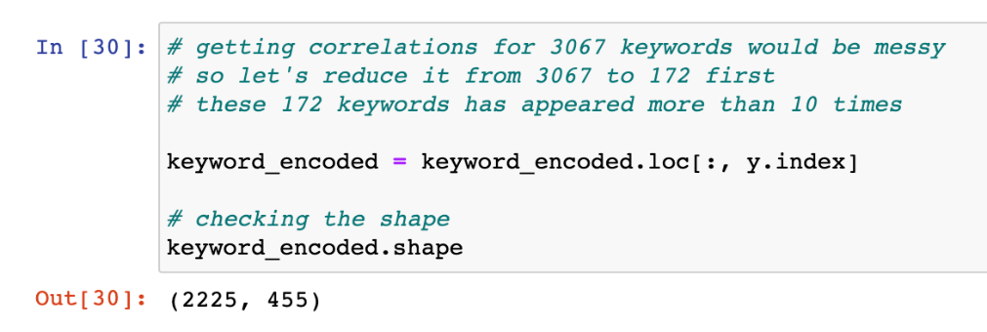

Since having 4145 number of columns is quite a large dataset, so to minimize the number of keyword columns by eliminating keywords that appeared less than 10 times in the document.

The finalized keyword_encoded has shorten to only 455 columns for association rule mining.

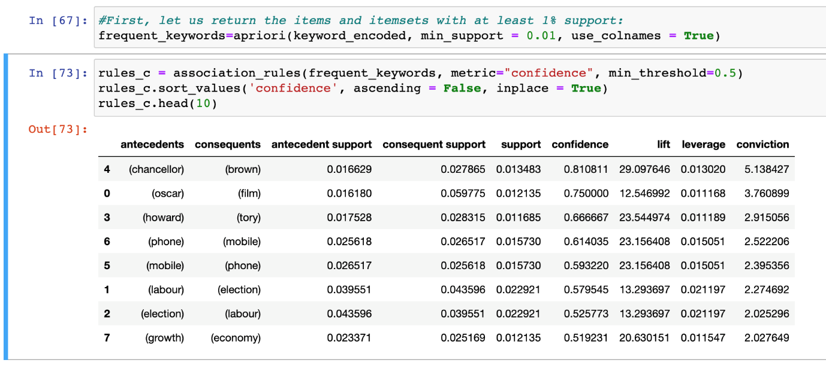

The code above shows how to use apriori algorithm for association rule mining on the keyword_encoded matrix identified earlier on.

The min_support count for the apriori model is set to 0.01, meaning that it will only return the items and itemset with at least 1% support.

When creating the association rules using confidence metric, the minimum confidence is set to 0.5, which means that 50% and above of the time that **antecedents** appear in the document, the **consequents** also appear.

The lift value of an association rule is the ratio of the confidence of the rule and the expected confidence of the rule, whereas the expected confidence of a rule is defined as the product of the support values of the antecedent and the consequent divided by the support of the antecedent.

From the results, it also shows that the rules with high confidence score also tends to have high lift value, this indicates that the antecedent and the consequent appear more often together than expected, this means that the occurrence of the antecedent has a positive effect on the occurrence of the consequent. The higher the lift value of a rule, the more interesting the rule is.

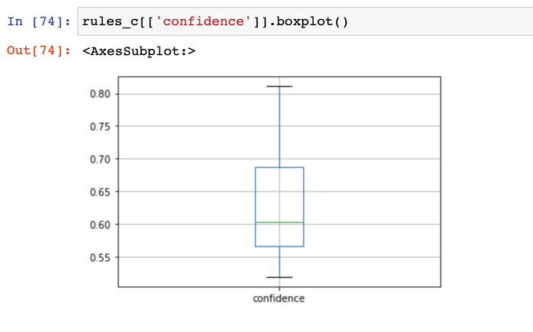

And lastly, a boxplot showing the distribution of confidence values in the model.

2.3 Association Rule Mining on Keywords – By category

The steps for performing association rule mining on text data in each category is almost the same as the above, except that the keywords extracted are filtered to that category.

2.3.1 Sports

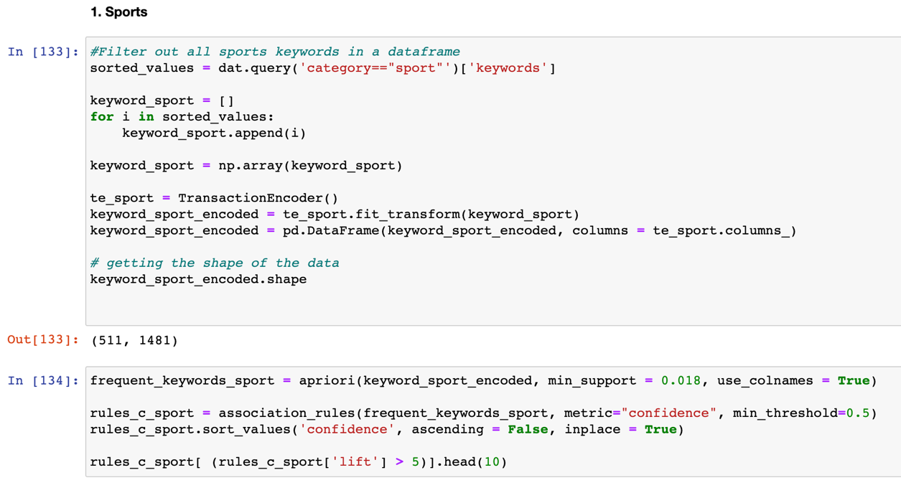

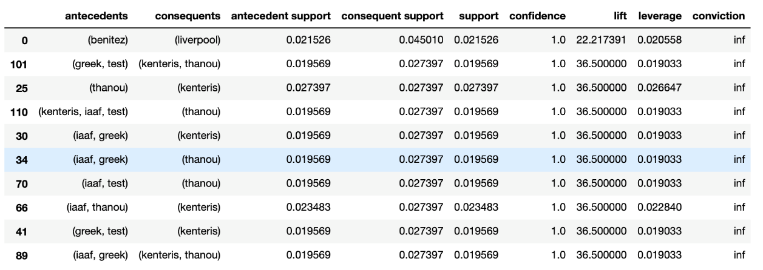

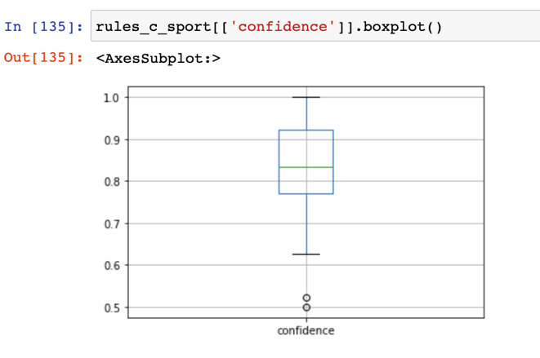

2.3.2 Business

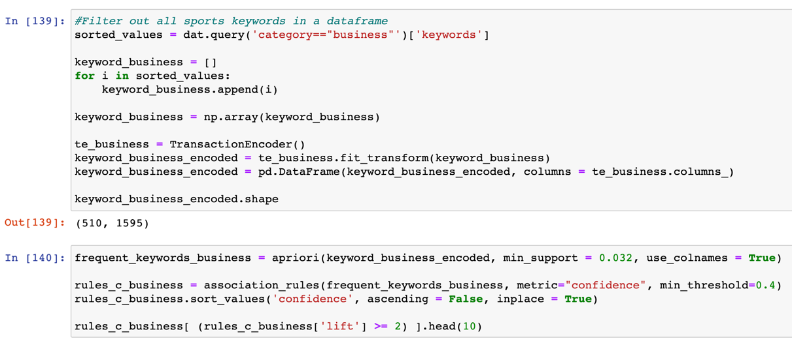

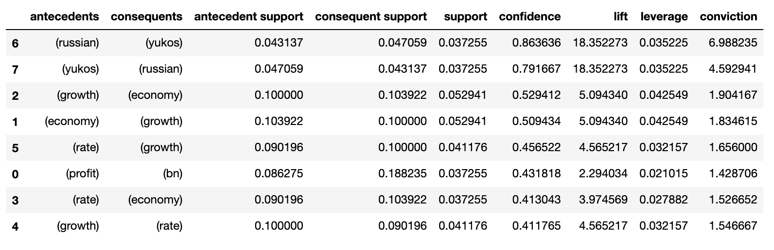

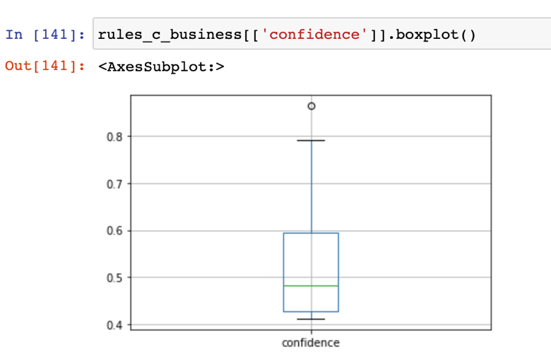

2.3.3 Politics

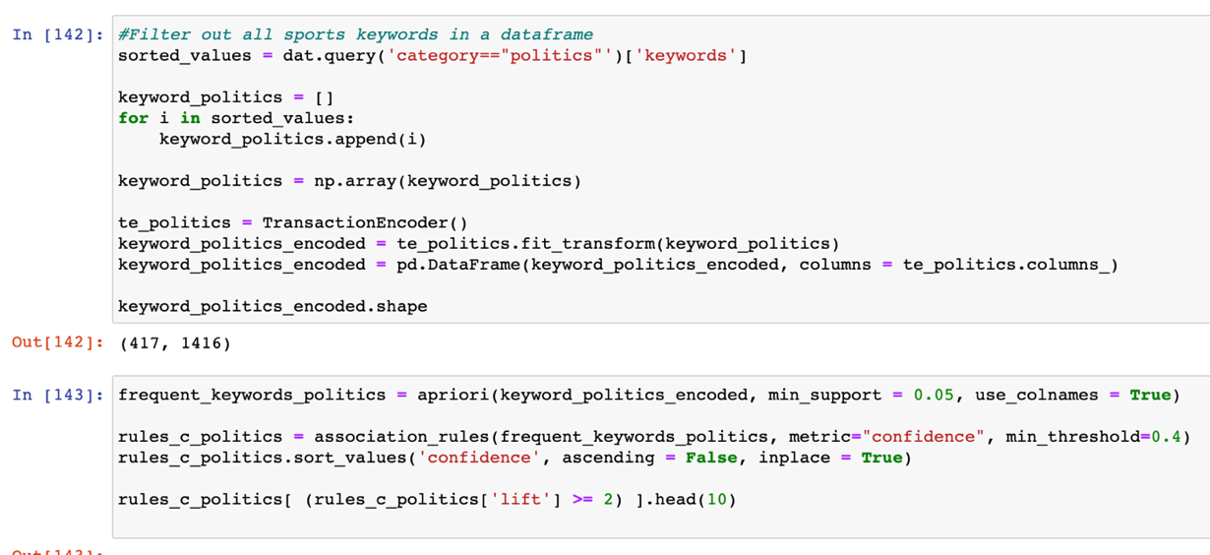

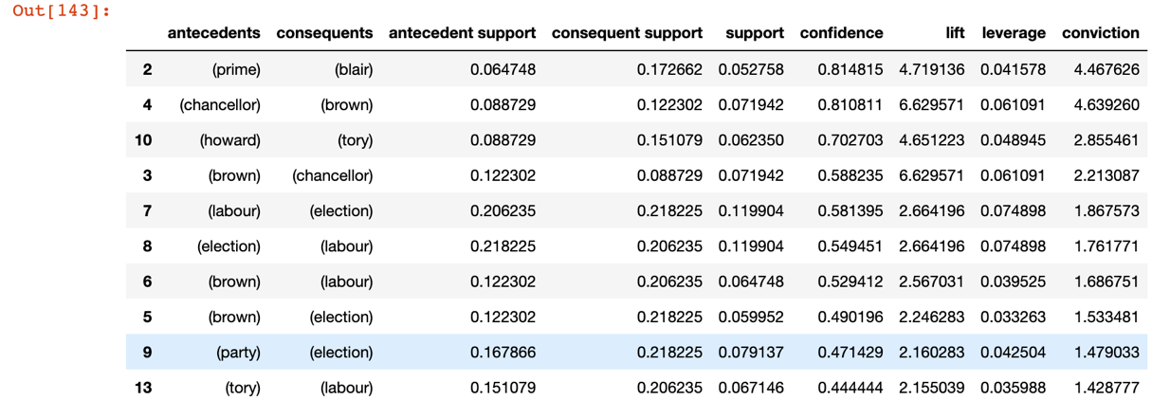

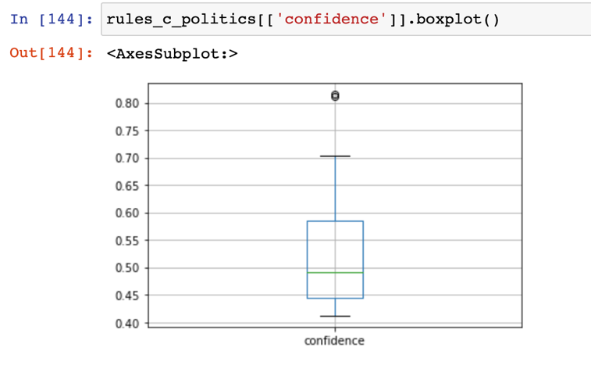

2.3.4 Tech

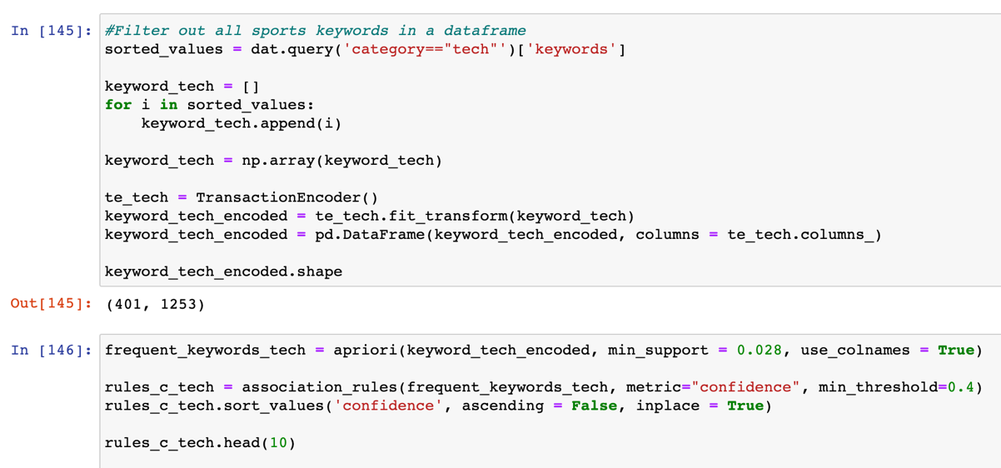

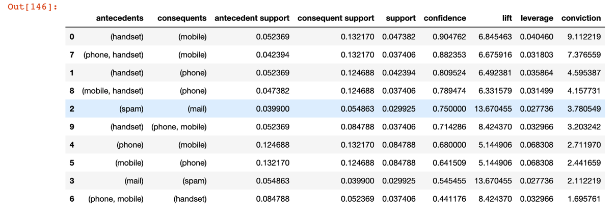

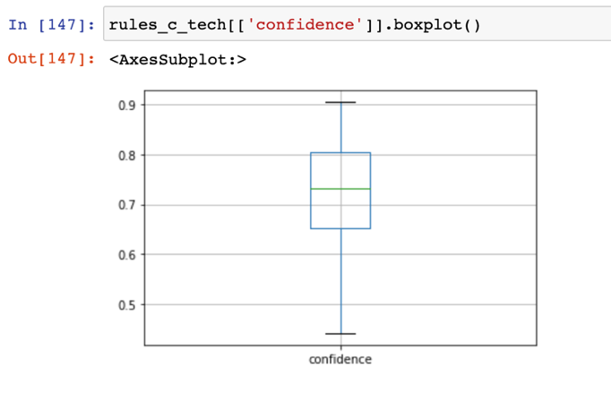

2.3.5 Entertainment

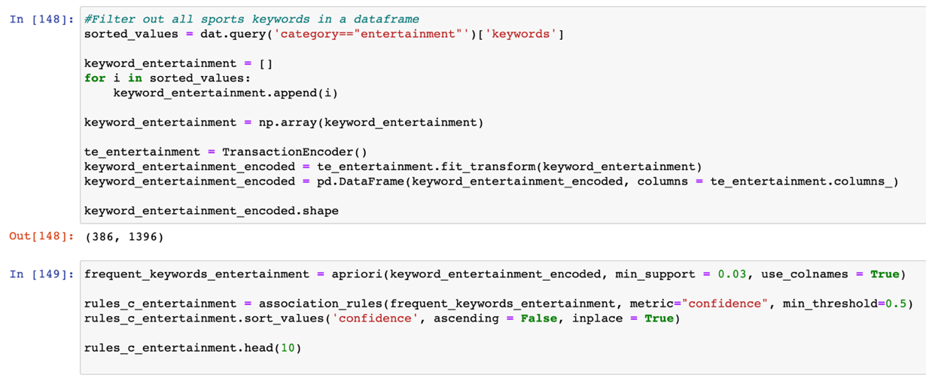

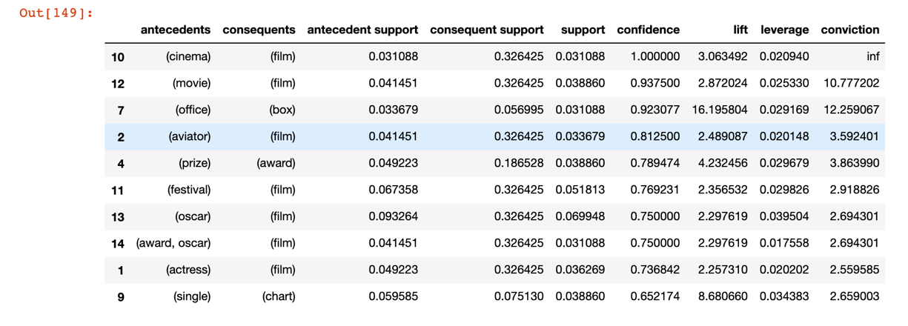

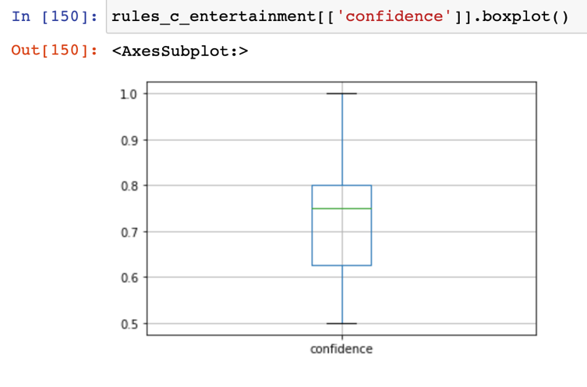

**Step 3 – Classification Modelling**

At the end of step 1, we have obtained two arrays, first is text_bow, which is the word count of each word appeared in the 2225 documents. Second is text_tdidf, which contains the TF-IDF scores of each word among the documents. These two arrays will be the data input for classification modelling in this step.

3.1 Research on classification models to tackle the problem

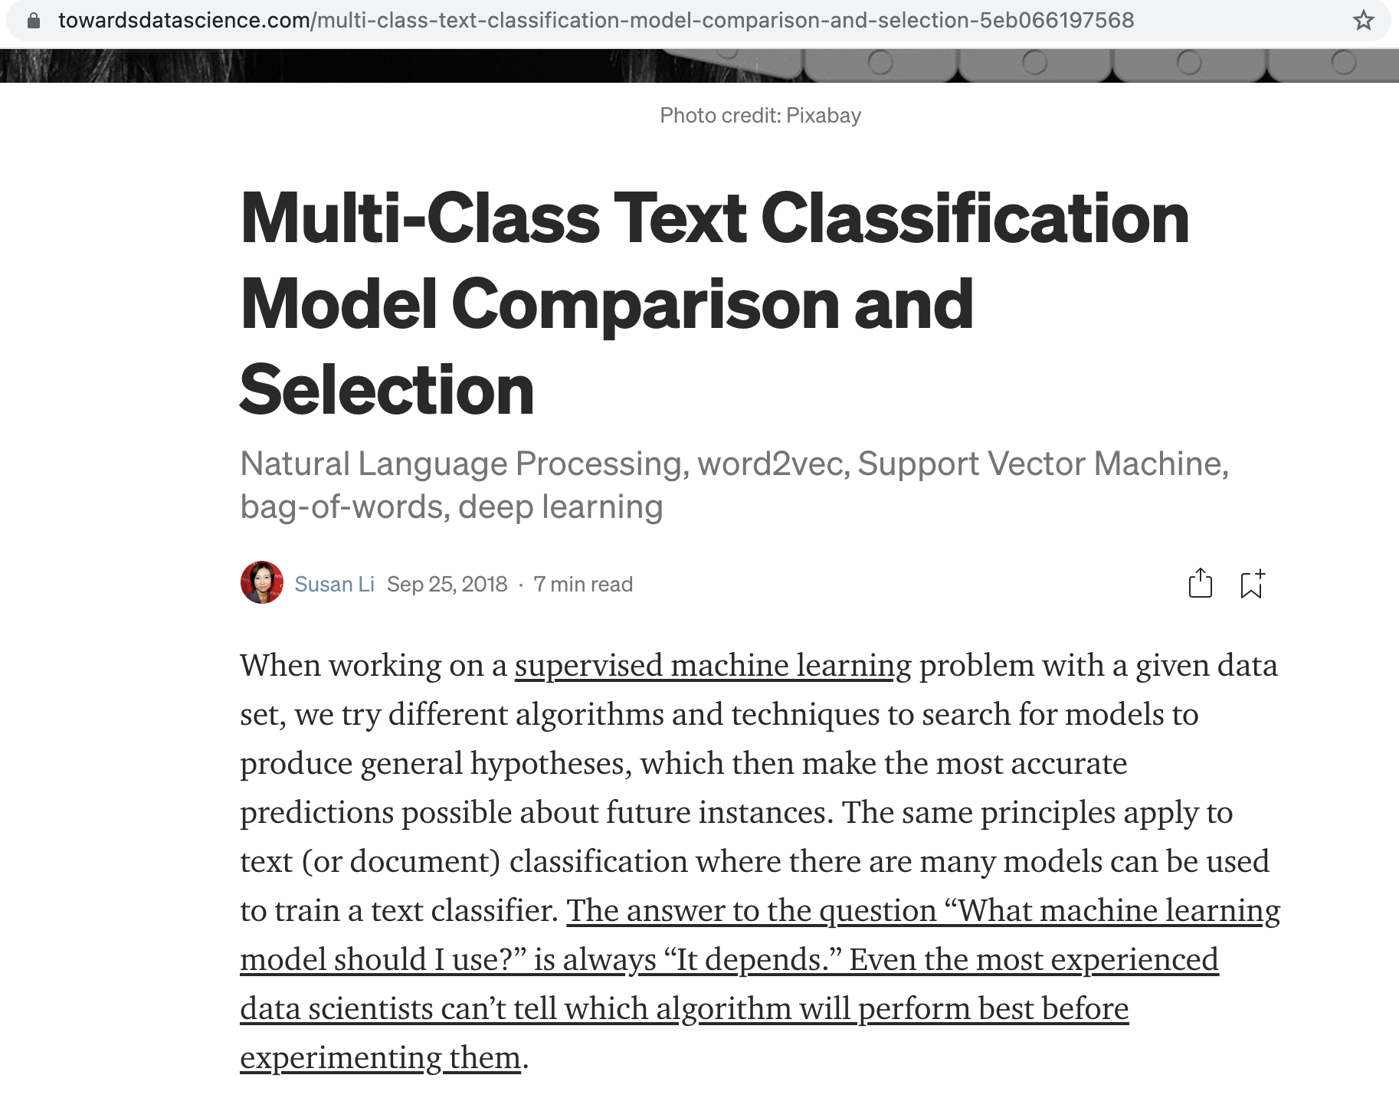

*Source: https://*[*towardsdatascience.com/multi-class-text-classification-model-comparison-and-selection-5eb066197568*](https://towardsdatascience.com/multi-class-text-classification-model-comparison-and-selection-5eb066197568)

Finalized three models chosen for the classifying text with multiple classes.

1. Logistic Regression
2. Linear SVM – SGD Classifier
3. Random Forest Classifier
   1. Logistic Regression

* Logistic regression is a supervised learning classification algorithm used to predict the probability of a target variable. In this case, since we have 5 labels, we use multinomial logistic regression.

Part 1: Using bag-of-word matrix

3.2.1 Sampling the data

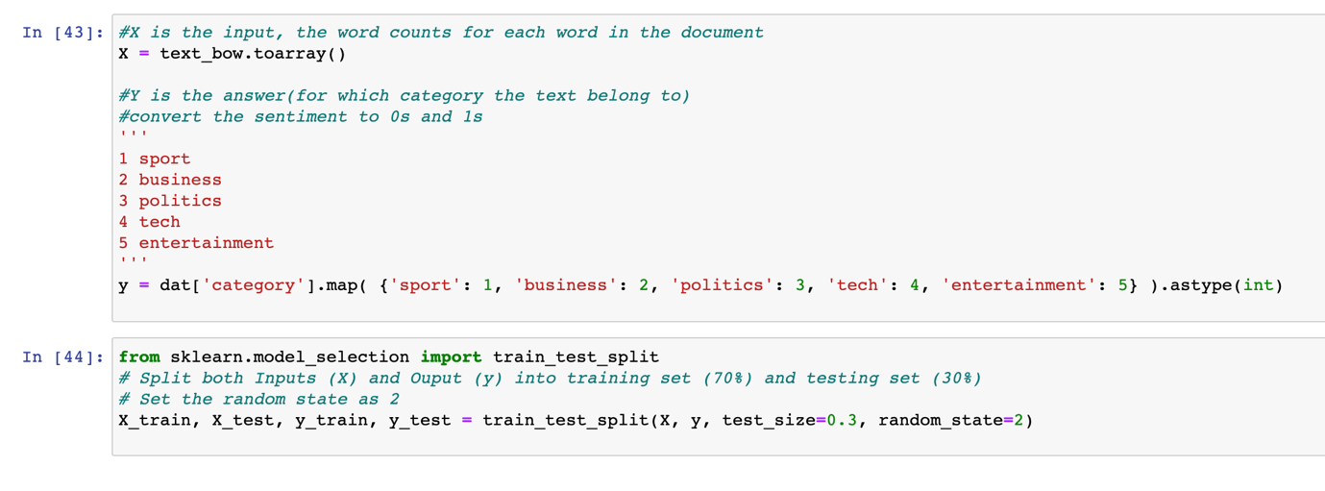

The first step for classification modelling is to sample the data into X and y training and testing subsets. Whereas X is the input, the bag-of-word matrix – text_bow identified earlier in step 1. Then for y, it is the label for the X input, which means the five categories relating to the text data. Since the computer can only understand numbers, each category has to map to a number for processing. “Sport” is mapped to 1, “Business” is mapped to 2, “Politics” is mapped to 3, “Tech” is mapped to 4 and “Entertainment” is mapped to 5.

The X and y subsets are also splited into X_train, X_test, y_train and y_test in a 70/30 split. This allows the computer to fit the 70% training data into the classification model and use the remining 30% testing data to evaluate the model performance like accuracy.

3.2.2 Build the Model

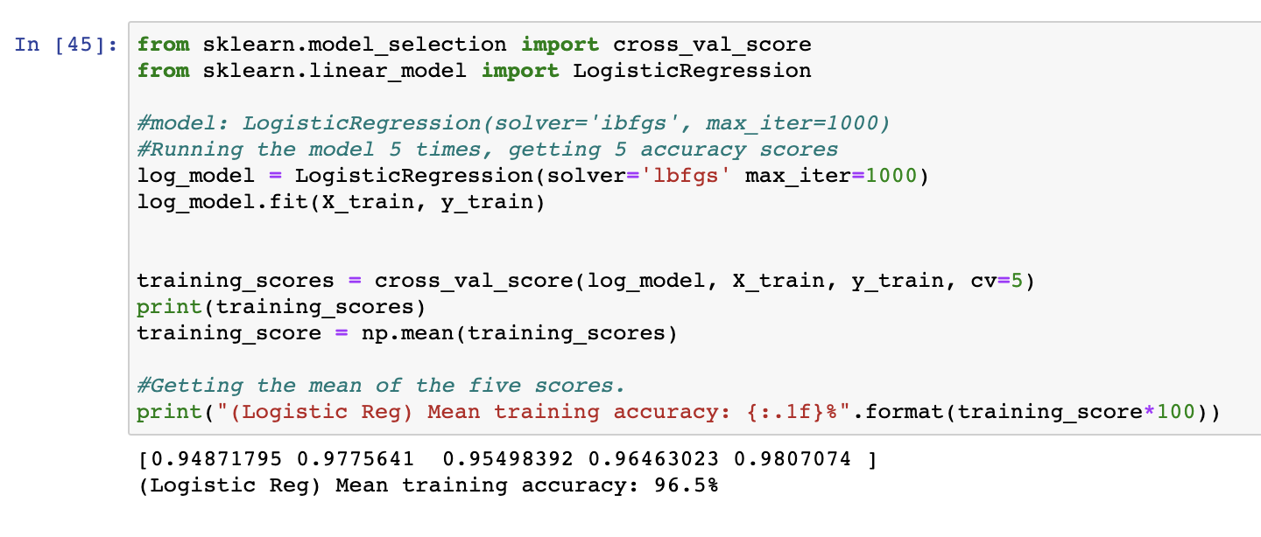

Next, by importing Logistic Regression model from sklearn.linear_model library, initialize the model with solver=”lbfgs”, this allows the model to handle multinominal loss since this is a multiclass problem. Then, set the max_iter to 1000 which is the maximum number of iterations for the solver to converge.

Next, fit the X_train and y_train dataset into the model, use cross_val_score function to calculate the mean training accuracy score of the model after running it for five times (cv=5).

The mean training accuracy for Logistic regression on bag-of-word matrix is 96.5%.

3.2.3 Evaluate the Model

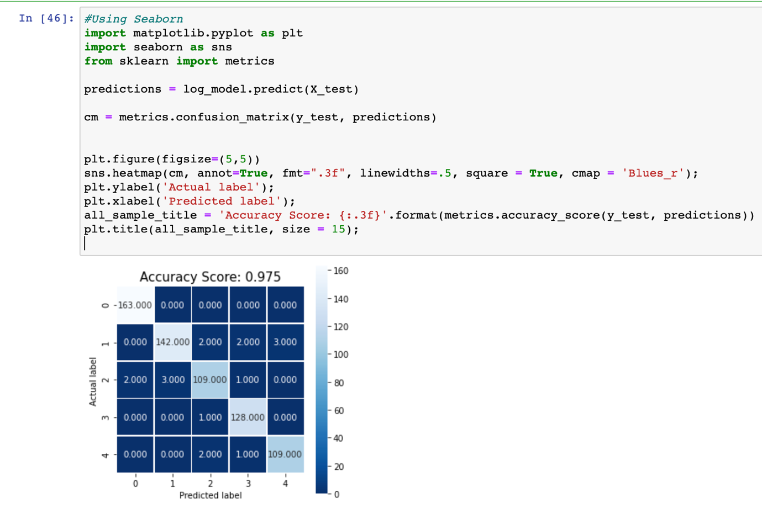

This step evaluates the model performance by using confusion metrics, drawn with seaborn to visualize the data. The accuracy score calculated with y_test is 0.75, the linear line across the graph (white boxes) shows the correct predictions on the predicted labels over actual labels. Whereas for the dark color boxes, these are wrong predictions, for example, in row 2 column 0, it shows 2 times that model predicts the label as 0 (Sport), however, the actual label is 2 (Politics). This helps us to see where the model got wrong.

3.2.4 Improve Model using GridSearchCV

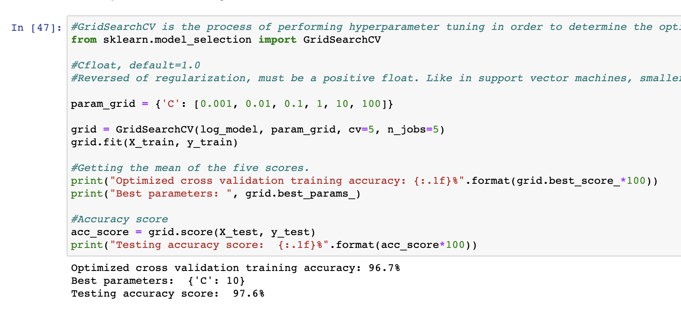

GuidSearchCV is the process of performing hyperparameter tuning in order to determine the optimal values for a given model. In this classification model, the hyperparameter chosen for tuning is C (default is 1.0), which is the inverse of regularization strength, like in support vector machines, smaller values specify stronger regularization. First by declaring a range of values for C, from 0.001 to 100, then fit the X_train and y_train data into gridSearchCV model with param_grid set to C values.

The optimized mean training accuracy is now improved to 96.7%, which has increased by 0.2% (from 96.5%), and it shows that the best parameter for C value is 10.

Lastly, use the 30% test dataset to obtain a testing accuracy of 97.6%.

Part 2: Using TF-IDF matrix

3.2.1 Sampling the data

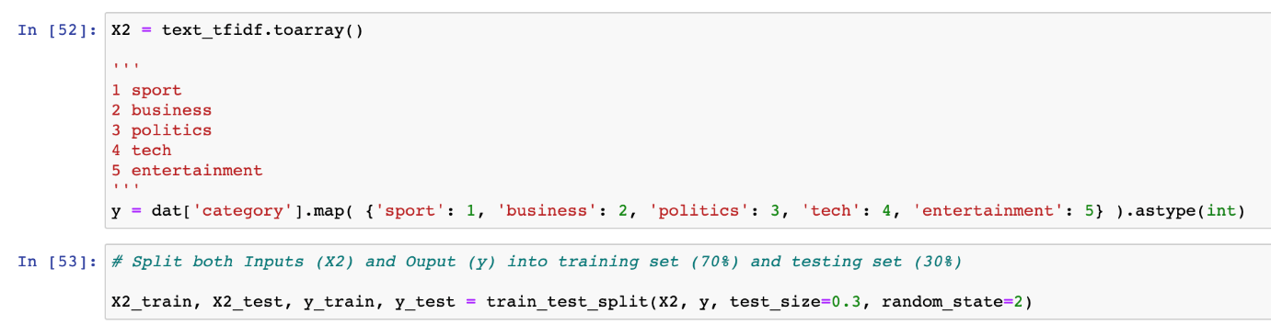

The sample method is almost the same as above, however, instead of using text_bow as input, now use text_tdidf matrix as input and name it as X2.

The train test split is set to 70/30 too, the input data is also changed to X2_train and X2_test.

3.2.2 Build the Model

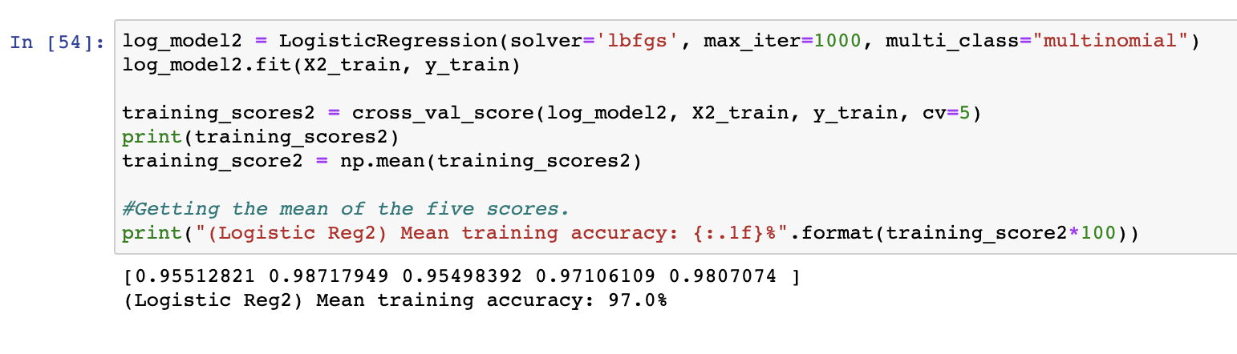

After fitting X2_train and y_train subsets into the logistic regression model, the mean training accuracy is 97.0% after running the model five times.

3.2.3 Evaluate the Model

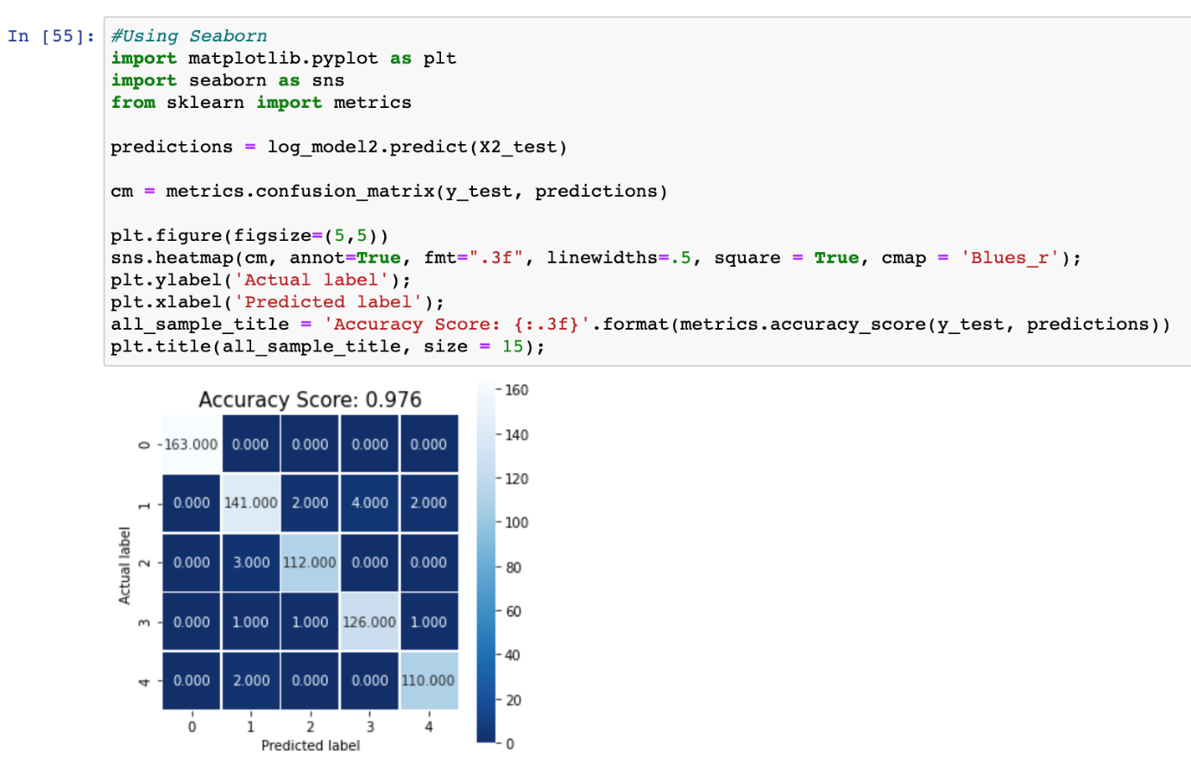

The accuracy score gotten is 0.976 using the confusion matrix. Which is higher than the previous model using bag-of-words as input data.

3.2.4 Improve Model using GridSearchCV

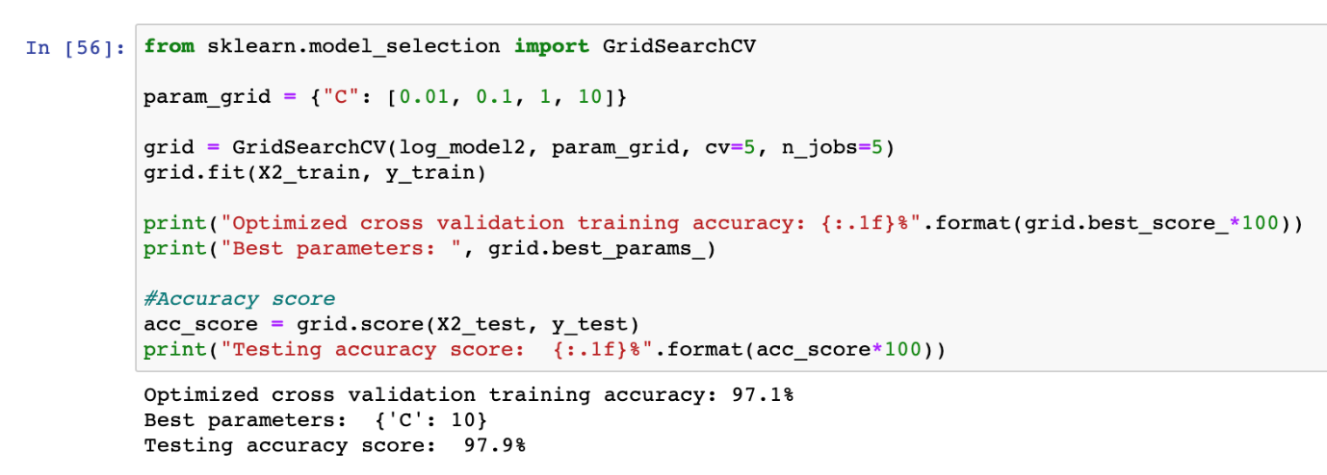

By using GridSearchCV to perform hyperparameter tuning on C parameter, the optimized mean training accurary is 97.1%, the best C parameter is 10 and the testing accuracy score is 97.9%. This shows that logistic regression model using TF-IDF as input has much higher accuracy than using bag-of-words as input.

* 1. Linear SVM – SGD Classifier
* The name SGD stands for Stochastic Gradient Descent, which is a linear classifier but using optimization method to minimize the loss function.

Part 1: Using bag-of-word matrix

3.3.1 Build the model

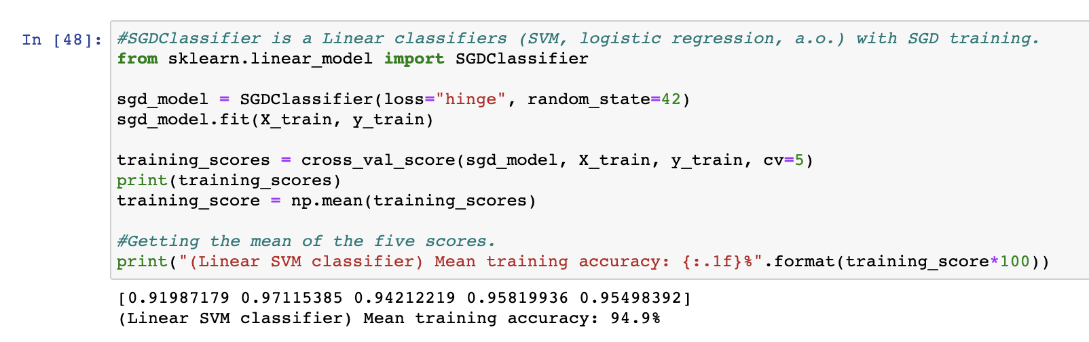

The “loss” parameter in the SGDClassifier model is set to “hinge” to give a linear SVM. There are other loss functions such as  ‘log’, ‘modified_huber’, ‘squared_hinge’, ‘perceptron’, ‘squared_loss’, ‘huber’, ‘epsilon_insensitive’, or ‘squared_epsilon_insensitive’.

3.3.2 Improve Model using GridSearchCV

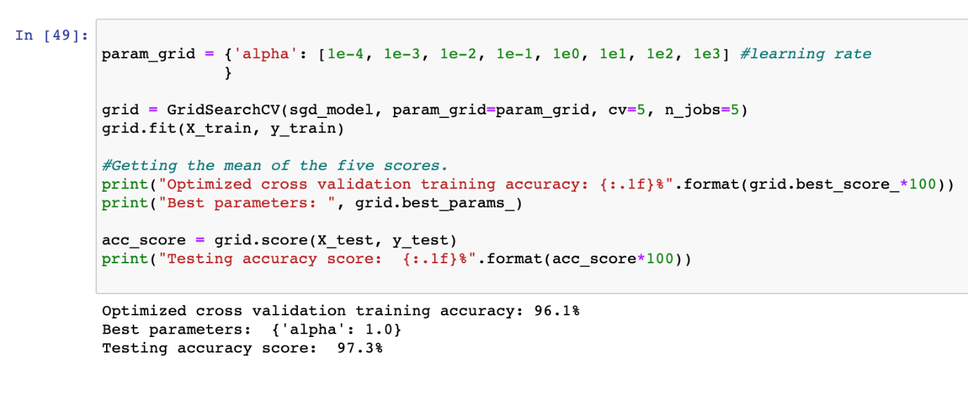

Next up for hyper-parameter tuning using GridSearchCV, the hyperparameter chosen is “alpha” value, which is a constant that multiplies the regularization term. The higher the value, the stronger the regularization. The optimized mean training accuracy is improved tremendously to 96.1% (+1.2%). The testing accuracy score is 97.3%.

Part 2: Using TF-IDF matrix

3.3.1 Build the model

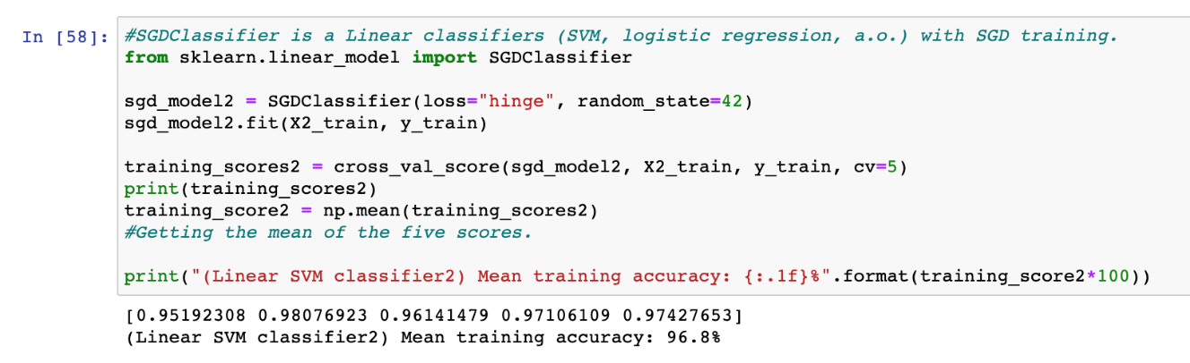

Next, to build SGDClassifier model using TF-IDF matrix as input, the mean training accuracy is 96.8%.

3.3.2 Improve Model using GridSearchCV

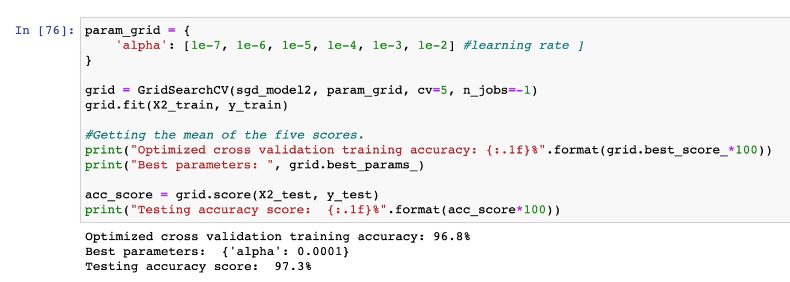

Next up for hyper-parameter tuning using GridSearchCV, it seems there are no changes to the mean training accuracy using alpha as hyperparameter tuning, the testing accuracy score is 97.3%.

* 1. Random Forest Classifier
* Random forest is a supervised learning algorithm. It can be used both for classification and regression. It is also the most flexible and easy-to-use algorithm.
* A forest is comprised of trees. It is said the more trees it has, the more robust a forest is. Random forests creates decision trees on randomly selected data samples, gets prediction from each tree and selects the best solution by means of voting. It also provides a pretty good indicator of the feature importance.

Part 1: Using bag-of-word matrix

3.4.1 Sampling and Build the model

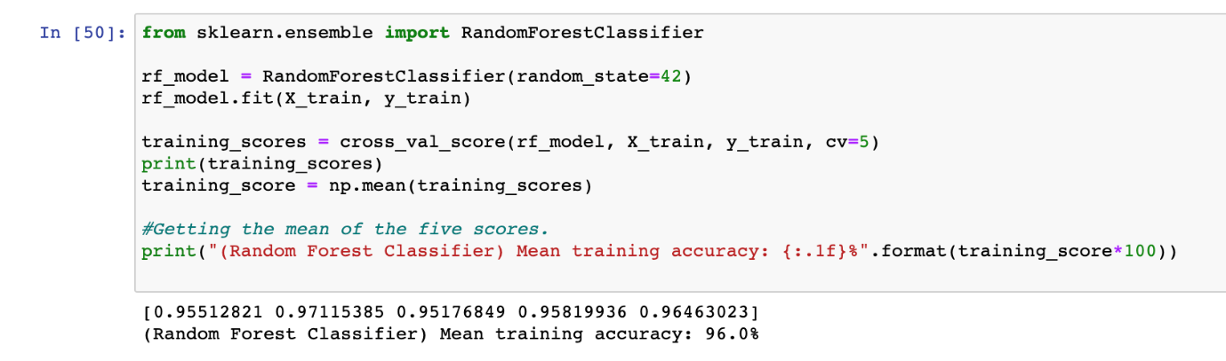

Random forest classifier is quite flexible, it produces a great result even without hyper-parameter tuning. The mean training accuracy gotten is 96.0% for using bag-of-word matrix as input.

3.4.2 Improve Model using GridSearchCV

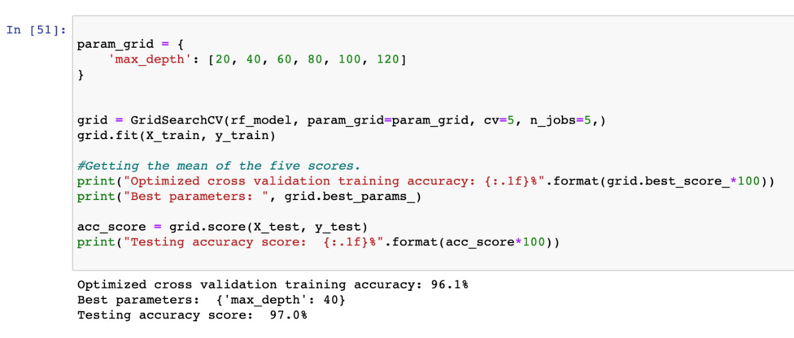

The hyper-parameter chosen is max_depth, which stands for the maximum depth of the tree. The optimized mean training accuracy is 96.1% which has 0.1% improvement, the best parameter for max_depth is 40 and the testing accuracy score is 97.0%.

Part 2: Using TF-IDF matrix

3.4.1 Build the model

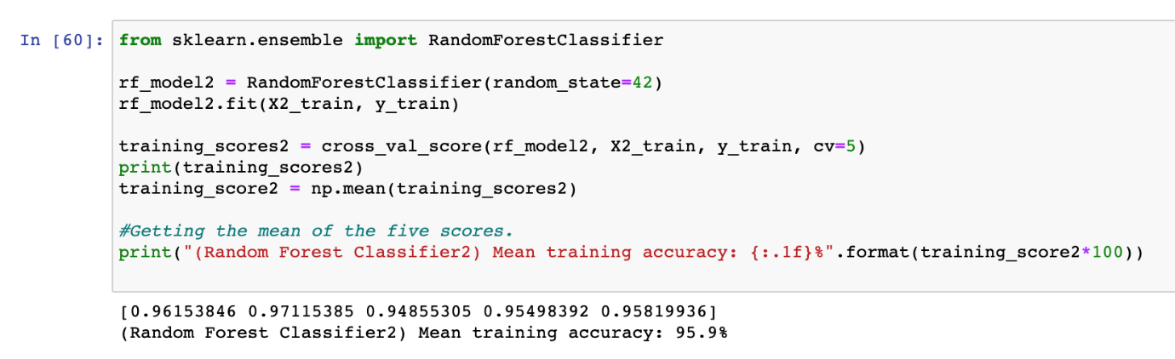

Next, using TF-IDF matrix as input to fit into Random Forest Classifier, the mean training accuracy is 95.9%.

3.4.2 Improve Model using GridSearchCV

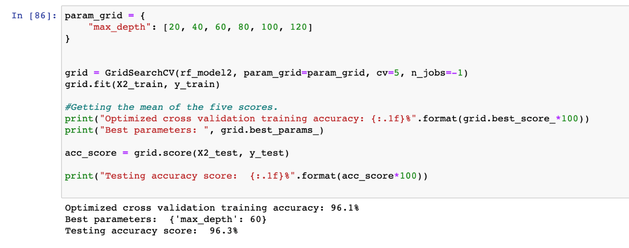

Using GridSearchCV for hyper-parameter tuning on max_depth, the optimized mean training accuracy is 96.1% and the testing accuracy is 96.3%.

**Step 4 – Summary and Further Improvements**

4.1 Summary

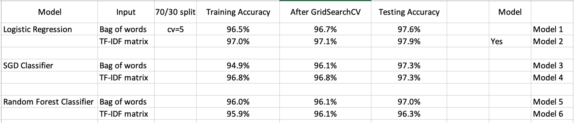

This is the model improvement table, a collection of all training and testing accuracy of the three models using two different inputs. For the purpose of a fair comparison, other factors that might affect the result are set to a fixed value such as the train test split ratio (70/30) and the number of times the models run to get the training accuracy score (cv=5). The hyperparameter used for tuning in GridSearchCV for both of the inputs are the same too. From the result, it shows that Model 2, which is the Logistic Regression that uses TF-IDF matrix as input has the highest training and testing accuracy after optimized using GridSearchCV. This is the ideal model and input used for classifying text data in the future.

4.2 Further Improvement

There are other classification models to try out and see if one can achieve higher accuracy than Logistic Regression. So one further improvement that I could do is, trying out naïve bayes classifier. Specially, using MultinomialNB which is suited for multinomially distributed data.

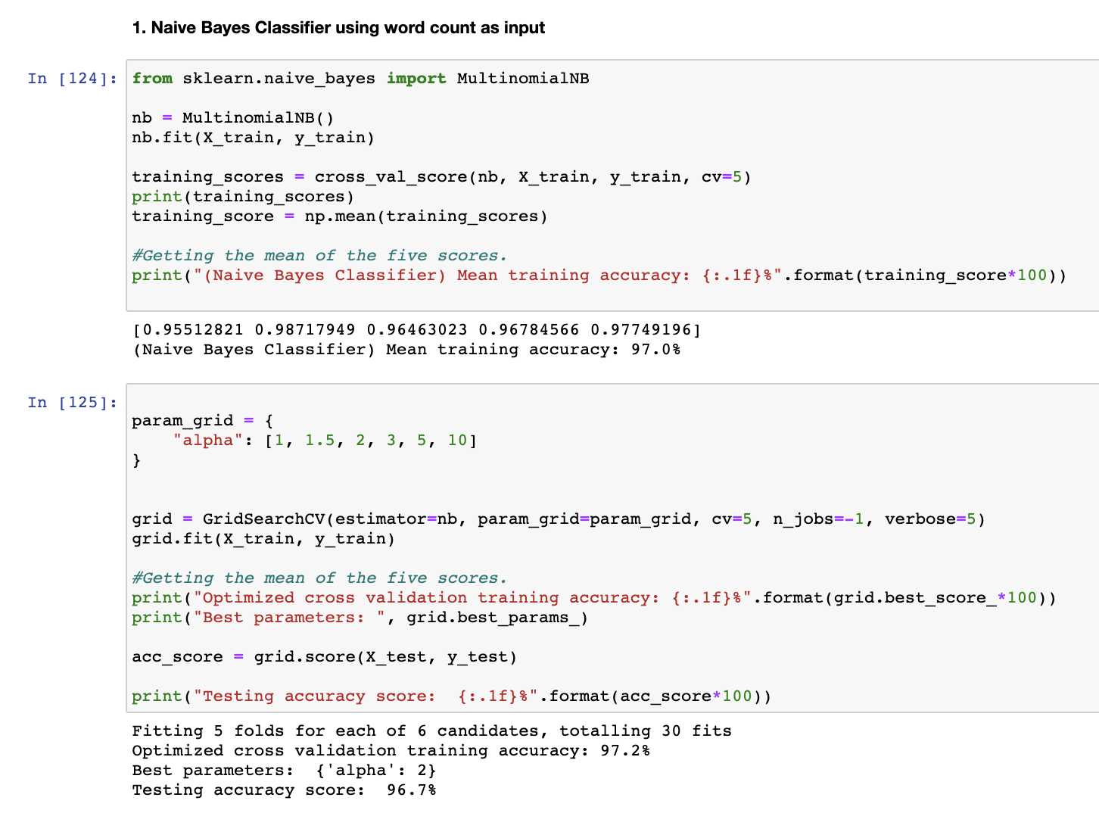

The training accuracy for naive bayes classifier (bag-of-word) is 97.0% and using GridSearchCV, it improved to 97.2%. The training accuracy score gotten is 96.7%.

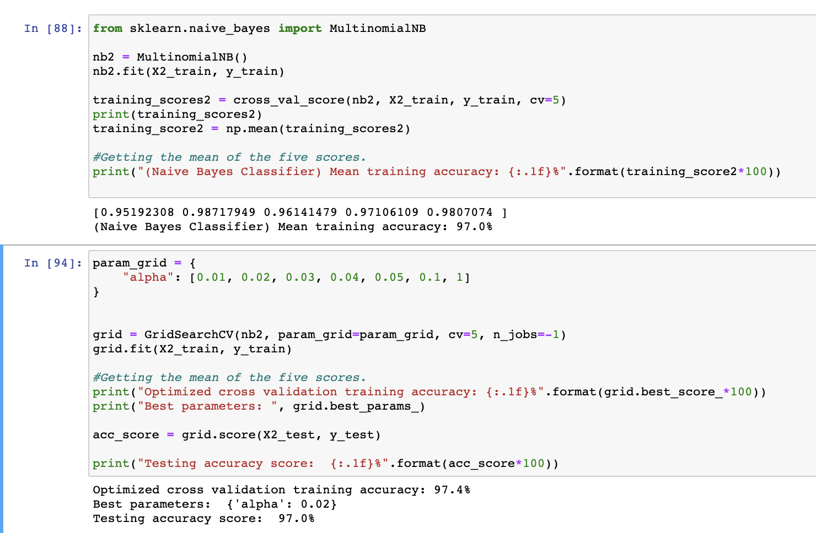

The training accuracy for naive bayes classifier (bag-of-word) is 97.0% and using GridSearchCV, it improved to 97.4%. The training accuracy score gotten is 97.0%.

This shows that MultinomialNB() model from naïve bayes Classifier can also do a decent job by achieving accuracy score of higher than 97%.

**References**

1. <https://towardsdatascience.com/multi-class-text-classification-model-comparison-and-selection-5eb066197568>
2. <https://www.datacamp.com/community/tutorials/random-forests-classifier-python>
3. <https://builtin.com/data-science/random-forest-algorithm>
4. <https://coderzcolumn.com/tutorials/machine-learning/scikit-learn-sklearn-naive-bayes#5>